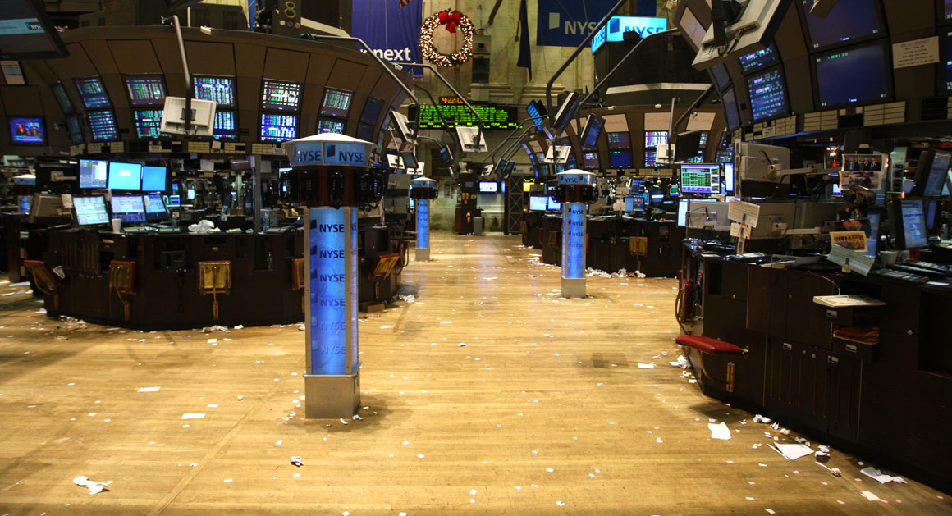
http://www.politico.com/agenda/story/2015/04/bitcoin-money-stock-market-000026
The Agenda

Bitcoin vs. the SEC
Forget money. Bitcoin 2.0 is about to disrupt everything else. Are regulators ready for it?
By Ben Schreckinger

A couple of miles from Wall Street, on the Western bank of the Hudson River, sits a vault in Jersey City maintained by the Depository Trust & Clearing Company. You might never have heard of the DTCC, but if you own stock, bonds or a mutual fund, it takes care of something that belongs to you.
The DTCC is the clearinghouse for U.S. capital markets. Its Jersey City vault contains about a million physical stock and bond certificates, representing some undisclosed portion of the $43 trillion in total assets the organization holds in custody. This is the center of the entire American stock-trading system. Each share has an owner, and – no matter how fast it changes hands – a clearinghouse keeps track of who owns what.
This year, Patrick Byrne, the CEO of Overstock.com and would-be financial revolutionary, is taking the first steps in a campaign to smash open the vault. Or, really, to eliminate it - and with it, the whole system that makes the vault necessary. On April 1, the Securities and Exchange Commission approved a request by a private stock exchange partnered with Overstock to deal in “digital securities.” On April 24, Byrne filed a Form S-3 with the Securities and Exchange Commission to register $500 million worth of equity in Overstock as the first digital stock, which the agency is currently reviewing. On Friday, the company offered the world’s first-ever digital security, a corporate bond that does not need SEC approval and could be issued in a matter of days.
Byrne wants to use the technology behind Bitcoin to create a securities market that exists not in any one particular place, but as a collection of data distributed across computers anywhere on Earth, with no need for the DTCC, the New York Stock Exchange or any of the other middlemen who oversee the world’s capital markets.
This new system, which he calls Medici, after the banking family that ruled over Renaissance-era Florence, would do something no other stock exchange has ever done. It would skip the centralized clearinghouse entirely, and keep track of trading, clearance, and ownership on everyone’s computers at once. It would transform processes that now depend on centralized institutions for trust, and let people instead transact directly with one another.
By approving these new securities, the SEC has made the federal government’s first foray into regulating Bitcoin 2.0, a technological force on the cusp of sweeping into the mainstream.
When people talk about the real potential of Bitcoin to transform the financial system, they aren’t talking about a digital currency that may or may not ever really take off. They are talking about what Byrne and other Bitcoin 2.0 entrepreneurs are trying to do.
The engine that powers Medici is a new technology called the “blockchain” – the complex, novel computer code that made Bitcoin possible. Unlike an exchange or a clearinghouse, the blockchain – invented and published in 2008 by a mysterious cryptographer known only by the pseudonym Satoshi Nakamoto – is completely decentralized.
The geeks, lawyers and entrepreneurs who spend their days thinking about the blockchain believe that after it’s done with securities markets, it’s poised to disrupt the way we make and enforce contracts, import and export goods, buy and sell digital media, gamble and even vote. They say it will be as revolutionary as the Internet itself, and pose regulatory challenges that are just as far-reaching — not just for FinCen and the SEC, but for Congress, the CFPB, the CFTC, the FTC, the FEC and others. Already, solitary tinkerers and Fortune 100 companies alike are test-driving applications that will demand the attention of many of these agencies.
“For the first time in human history, we can have peer-to-peer exchange where trust is not an issue,” says Byrne, who predicts Bitcoin 2.0 will put much of Wall Street out of business. “This is going to separate the men from the boys.”
For the past 6 years, since the creation of Bitcoin in 2009, regulators have been wrestling with what to do about a “currency” that completely bypasses the central institutions that have helped stabilize money for centuries. Instead of depending on banks, or governments, or bars of gold to establish value and credibility, the bitcoin system creates digital money at a predictable rate, establishes un-forgeable digital signatures for all the players in a market to verify their transactions, and forces every actor to maintain their own record of everyone else’s transactions. So at any given time, anyone in the Bitcoin market is helping verify the behavior of the entire market.
As a result, a lot of activities that required governments or other trusted intermediaries to keep track of things and keep everyone honest can now run on computer programs that belong to no central authority. The original Bitcoin code, for example, creates and transfers money without oversight from the Federal Reserve, highly regulated private banks or anyone else.
That can raise red flags for regulators, and the anti-government ideology spouted by many Bitcoin and blockchain supporters hasn’t helped. The technology is hugely popular with libertarians who are actively rooting for it to usurp national governments’ power over the money supply. Its most enthusiastic early adopters were online black markets. In May, a federal judge in Manhattan sentenced Ross Ulbricht, the founder of Silk Road, an online drug bazaar that ran on anonymous Bitcoin transactions, to life in prison without parole.
It took two years from the cryptocurrency’s inception at the beginning of 2009 for the market value of a Bitcoin to reach $1. Bitcoin’s novelty and relatively low trading volume has made it extremely volatile, and it’s gone through ever-bigger boom and bust cycles since. Its value peaked at over $1000 per “coin” in late 2013, helped along by fears that the European sovereign debt crisis would bring down the euro and its utility in facilitating illegal online transactions. A whole global industry has even sprouted up to build computer servers specially designed for bitcoin “mining,” the complex calculations that help unlock new currency.
But even as Bitcoin became a household name, at attracted attention from entrepreneurs and venture funds, the currency’s value has come down to earth (now hovering between $200 and $300 per coin, with a total market size of about $3.5 billion), while the efforts of entrepreneurs and venture capitalists have increasingly migrated elsewhere.
Understandably, all of the Bitcoin buzz also caught the attention of government regulators. Many Bitcoin backers give American regulators credit for their restraint: Rather than try to eradicate Bitcoin, federal agencies moved to regulate it, or at least set some baseline rules to protect users.
In March 2013, the Financial Crimes Enforcement Network issued guidelines that said digital currency exchanges had to comply with federal anti-money laundering laws. In July 2013, the Winklevoss twins – the entrepreneurs who sued Mark Zuckerberg for allegedly stealing the idea for Facebook from them at Harvard -- filed to register a Bitcoin ETF, which would let investors easily trade shares of Bitcoin on the stock market. That scheme is still awaiting SEC approval. In March 2014, the Internal Revenue Service stated that Bitcoin should be taxed as an asset rather than as currency. In May, the SEC issued an investor alert warning about the risks of investing in virtual currencies; in August, the Consumer Financial Protection Bureau issued an advisory about risks to consumers.
There are also inklings of potential turf wars. In October, the Treasury Department’s Financial Crimes Enforcement Network clarified that companies that facilitate Bitcoin payments or act as Bitcoin brokers will be regulated as money transmitters. In November, a commissioner of the Commodities Futures Trading Commission asserted that Bitcoins were commodities and that the CFTC has the authority to intervene if Bitcoin prices are being manipulated, a position that could set up jurisdictional turf issues if the SEC decides it wants to regulate the cryptocurrency as a security. (Along the way, the SEC has pursued enforcement actions against various Bitcoin enterprises, including a Texas-based Ponzi scheme, for infractions that are not particular to digital currency.)
In popular coverage, Bitcoin itself tends to be the focus of attention, either breathlessly hyped or dismissed as some kind of doomed techie challenge to the dollar. But among people paying close attention, whatever happens to Bitcoin is seen as only the first act. Whether or not Bitcoin itself thrives, more important applications of its technology are likely still on their way.
Byrne and other financial entrepreneurs believe it will rewrite the rules of the financial system by taking out middlemen. Because it gives users anonymity while guaranteeing the authenticity of their actions, other believe it will allow e-voting to become the accepted norm for elections around the world. Because the blockchain allows actors to interact in a trustless environment without a centralized overseer, engineers at IBM are making it the foundation of their version of the Internet of Things, in which our refrigerators and washing machines will have to autonomously interact with someone else’s delivery drones and maintenance robots.
As in the early days of the Internet, most of the applications probably haven’t been dreamt up yet. Take Uber, says, says Jason Somensatto, a Washington lawyer who deals regularly with the SEC and has taken an interest in what blockchain technology might someday do. “If we would have said that to our 1995 selves, that would’ve been crazy, right? You push a button and a car shows up.” And decades after the Internet’s inventions, this new application has spawned policy fights across the country.
“The comparison that you often hear between the blockchain and the early internet is an apt one. There was a lot of suspicion of the early Internet, a lot of dismissal of it as a toy,” says Jerry Brito, executive director of the blockchain-focused think tank Coin Center and a law professor at George Mason University
Although the U.S has been reasonably accommodating to Bitcoin itself, it hasn’t created regulatory clarity for the next round of blockchain applications.
A spokesman for the SEC declined to comment for this story, but lawyers who deal with the agency say that when it comes to financial novelties, the SEC tends to wait until something goes wrong rather than proactively issuing guidance. “A lot of the SEC’s focus is on not so much writing new rules and regulation as it is on detecting violations and enforcing the rules,“ says Somensatto.
That creates a chicken-and-egg conundrum for Bitcoin 2.0. On the one hand, “The SEC doesn’t have much of an incentive to go forth and create guidance that would address this situation,” says Somensatto. “This is not yet a very large industry, so it’s difficult to dedicate a lot of your resources.”
On the other hand, regulatory ambiguity makes it hard for the industry to grow to the point where it does demand the agency’s attention. “Until there’s clarity from the government, I think people are going to tread lightly,” says Aaron Wright, a professor at Yeshiva University’s Cardozo School of Law who is co-authoring a book on legal issues posed by the blockchain. “If the U.S. thinks about this the right way, just like with the Internet, we’ll probably end up dominating it.”
People working on this next wave of blockchain technology say that the UK government, especially the Financial Conduct Authority, has done more than US regulators to signal that it’s open for Bitcoin 2.0 business. Through its Project Innovate, the FCA hand-holds businesses through the regulatory hurdles to launching novel financial products, and even pledges to “identify areas where our regulatory framework needs to adapt to enable further innovation in the interests of consumers.”
Entrepreneurs appreciate the enthusiasm. Joel Dietz, the founder of Swarm, a blockchain-based crowdfunding platform, has found the FCA’s innovation group engaged and easy to work with. He feels differently about the SEC. “If you want to interact with them, you have to have a securities lawyer, and that lawyer’s going to charge you a thousand dollars an hour,” says Dietz. “It’s very, very cost-prohibitive for entrepreneurs, and I think the SEC milks that for all it’s worth. I don’t think they care about entrepreneurs very much.”
Lawyers who study the blockchain say that the courts will determine whether crypto-equity crowdfunding platforms like Swarm are in fact in the securities business, but Dietz says that if the U.S. doesn’t make space for Bitcoin 2.0 applications, entrepreneurs will simply go elsewhere. “The U.S. is far from the only place that people want to create organizations and fund them.”
Brito concurs. “I think that the US should take seriously the idea that if it doesn’t get its regulatory posture right that it could lose its innovative edge to the UK or any other jurisdiction that wants to be more forward-looking,” he says.
Ultimately, the blockchain is likely to touch every corner of the federal government. In the very near term, the Bitcoin market itself is beginning to take on new and more sophisticated shapes. Former bankers for Goldman Sachs and Morgan Stanley, among others, are developing futures in the currency and other derivatives that could help stabilize its price. When those hit the market, they’ll fall under the jurisdiction of the CFTC.
Blockchain-based “smart contracts,” which will be automatically self-enforcing without the need for court intervention, will pose their own sets of challenges. Already, Evan Greebel, one of the securities lawyers handling the Winklevoss Bitcoin ETF, said he knows of efforts afoot to create smart contracts for car leases that will automatically prevent lessees who default on payments from starting their Internet-connected cars. Surely, the CFPB and Elizabeth Warren will have something to say about that. Greebel says such contracts will have implications for the federal bankruptcy code as well.
He also predicts that import and export registries will soon migrate to the blockchain, a matter for the Federal Trade Commission to oversee. The technology is perfect for keeping track of chains of custody, so say goodbye to your local registry of deeds while you’re at it.
The National Association of Voter Officials is working with a startup called V Initiative that wants to put American elections on the blockchain and let people vote from their personal devices – a transformation that goes to the heart of government. And IBM’s running its Internet of Things initiative on Ethereum, a new blockchain protocol that’s an alternative to the original Bitcoin blockchain.
The blockchain’s radical decentralization raises a host of newer and even stranger possibilities – for instance, markets or gambling networks that exist only as the shared interactions of dozens of users, or millions. It is possible that an illegal activity could arise, even a very large one, with no operator to sue, threaten or shut down.
Because of the immense potential range of applications, the regulatory tone may have to be set by Congress or the White House. Brito of Coin Center points to the 1997 Framework for Global Electronic Commerce, which was created by an interagency task force in the Clinton administration and called for minimal government interference in the Internet, as a model for the blockchain. “You could take it word for word,” he says.
Byrne, who holds a PhD in philosophy from Stanford and made Overstock the first major retailer to accept Bitcoin last year, is ready for this brave new world. And he doesn’t believe the SEC, or anyone else, could really hold it back if it tried. The last time Byrne tangled with the agency – a stranger-than-fiction crusade over the inner workings of the stock market that involved organized crime, hedge fund billionaire Steve Cohen, and a full-page ad in the Wall Street Journal featuring the Overstock CEO holding Star Wars villain Darth Maul’s head in his hands – he prevailed. Now, he says the new regime at the SEC is more reasonable than the old. He’s confident the SEC will approve his stock filing, marking another baby step in what Byrne calls the “crypto-revolution.”
As for the later stages of that revolution, in which the blockchain’s most enthusiastic backers predict it will threaten the livelihoods not just of financial middlemen but many government institutions themselves, Byrne says the world as it is should not be taken for granted. “These central institutions didn’t come out of a burning bush.”

Authors:
Ben Schreckinger

